‘Tidal Wave of Technology’ Is Transforming Museums
April 16, 2013 7:20 AM
How can technology reinvent and deepen the museum experience? New York’s 92Y recently convened a panel of forward-thinking museum pros to tackle the question, and we sent writer Nancy Lazarus to report back on what the future of museums may look–and sound and feel–like.
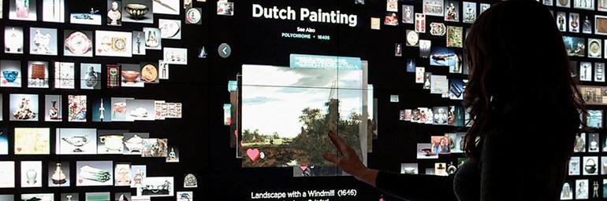
A visitor gets in touch with the Cleveland Museum of Art’s “Collection Wall,” a 40-foot, interactive, microtile wall featuring over 3,500 works of art from the permanent collection.
King Tut may finally have met his match: interactive technology. “Digital technology is as much a game-changer now for museums as blockbuster shows” were in the late 1970s, said Cara McCarty, curatorial director of New York’s Cooper-Hewitt National Design Museum. The Metropolitan Museum’s 1976 Tutankhamen exhibit was a pioneer of the blockbuster, and now many of the Met’s ancient treasures are also viewable on interactive touchscreens.
McCarty moderated a recent 92Y panel about technology trends and the future of museums. When she said, “Technology is hitting us all like a tidal wave,” she wasn’t lamenting, but referring to the overwhelming options. The panelists agreed, including Mark Robbins, director at New York’s International Center of Photography. “Nineteenth-century museums were comprised of a privileged set of objects,” he said. “Now museums offer more immersive experiences without walls.”
“Technology is a tool shaping museums’ future,” added Seb Chan, Cooper-Hewitt’s director of digital and emerging media. Interactive options enrich visitors’ experience, especially for storytelling. Chan described the mobile app at Australia’s Museum of Old and New Art in Tasmania. \It senses where gallery visitors are and delivers custom content, thereby eliminating wall labels. London’s Tate Museum has a similar app, the Magic Tate Ball, which promises, “It’s like having the Tate in your pocket.”
Another proponent of technology’s narrative power is Jake Barton, founder of Local Projects, a firm that designs media installations for museums. One client is New York’s 9/11 Memorial Museum, slated to open next year. He previewed an exhibit where visitors will use interactive maps to pinpoint their locations when they learned of the 9/11 news. Then they record messages about that moment, and their voices will play in the background as visitors view the exhibit.
“Museums are also more theatrical now,” noted Chan. They use design elements such as mirrors and project holographic images. He pointed to “High Arctic,” a 2011 exhibition about climate change that was organized by London’s National Maritime Museum, where visitors carried torches to activate projections on a sonic landscape.
“Technology provides the context for artworks,” Barton added, then cited the Cleveland Museum of Art, another client. In its Gallery One, visitors can turn tapestries into comic books or film trailers. They can also interact with touchscreens, making faces to express their emotions. The touchscreen then displays the museum’s artworks that match their mood.
Technology also plays a role in curation, digitization, and data analysis at museums worldwide, explained Chan “Building digital from the ground up” is a key objective of Cooper-Hewitt’s re:Design campaign. The museum analyzed the colors in its collection, which he said “creates new forms of curation.” They’ve also been incorporating 3-D scanning and printing techniques.
As museums take the plunge with high-tech tools, they need to strike the proper balance, panelists observed. As Robbins said, “We need to figure out why visitors are drawn to museum spaces, whether it’s more the art or being social.” Added Chan, “The challenge is to take technology in museums to the places where it makes the most sense.”
Nancy Lazarus is a contributor to UnBeige.

